Requisition Form
- Authors Information

Sr. No | Name | Address | Pin code | Nationality | Date Of Dispatch
1 | Ayush lalit Vaze | Dr. D Y Patil Institute of Technology, Pimpri | 411018 | Indian

- Applicants Information
Sr. No | Name | Communication Address | Pin code | Nationality | Phone No
1 | Dr. D Y Patil Institute of Technology, Pimpri | Dr. D Y Patil Institute of Technology, Pimpri | 411018 | Indian

- Category of Applicant: (Please Tick (X) for correct answer)

Individual | Business | Others
X

- Applicant Signature (Signature File type i) jpg and jpeg format. ii) File size Less than 512 KB
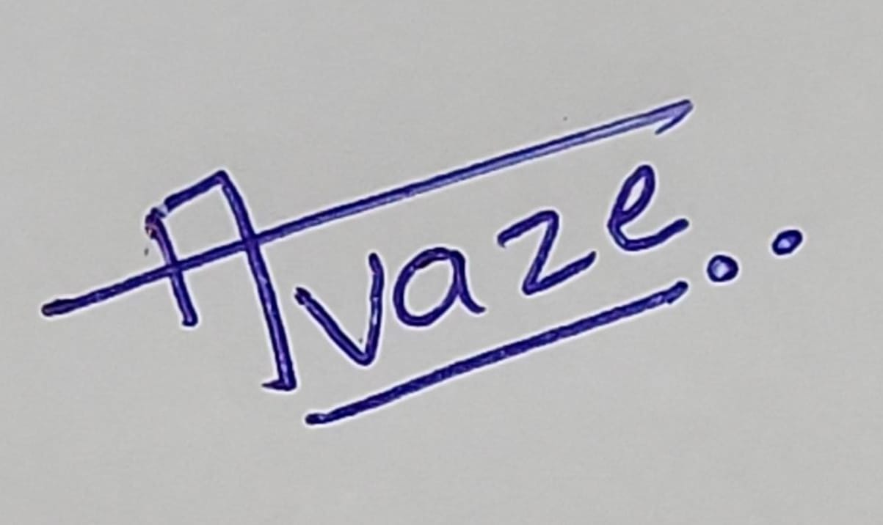

- Nature of the applicant's interest in the copyright of the work (Please Tick (X) for correct answer)

Author | Owner | Publisher | Composer | Producer | Artist
 | X

- Class of the work (Please Tick (X) for correct answer)
Literacy/Dramatic | Artistic | Cinematograph Film | Sound Recording | Music | Computer Software

- Description of the work (In 200 Characters):

- Title of the Work:

- Language of the Work: English

- Whether work is Published or unpublished? (Please Tick (X) for correct answer)
Published | Unpublished
 | X

- Document for Upload:
- You’re Literature (in .dox/.doc format).
Mail as separate file.

- If the work is published by a person other than the applicant, a No Objection Certificate in original may be obtained from the person/firm and enclose with the application.

- Please intimate the Name, address & Nationality of the person whose photograph appears on the work. If that person is other than the applicant, a No Objection Certificate, in original may be obtained from the person or from his legal heir(s) if the person is deceased or from the guardian if the applicant is minor and the same may be enclosed with the application.

Declaration applicants:
I/We all the applicants are hereby declare that, the information provided by us in this requisition form to research drafting team is true and not copied from anywhere. If this is so, it is our sole responsibility. In such cases Research Drafting Team do not responsible for any legal action.
Name and Signatures of applicants:

Date:24/09/2024
Place: Pimpri,Pune.

